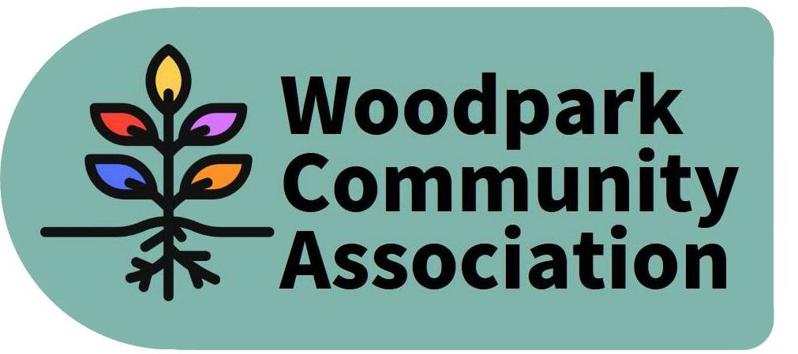
Monthly Meeting – 7:00 pm, March 10, 2021
MINUTES
Meeting held via Zoom. Minutes taken by Larry
Present: Ian, Stephen, David, Don, Rob, Tanya, Erica, Larry
Absent: Celeste (resigned), Tom, Jessica
- The Minutes of the February meeting were approved.
- President’s Report – Ian commented that communication with KEV does not appear to have improved since our last meeting. A site tour has been cancelled several times. There has been poor communication regarding planned water shutoffs. 11 people attended a meeting organized by the Councillor concerning traffic calming measures. The City planners who attended appear to be fixated on measures designed to facilitate traffic movement. It could be important to have baseline traffic counts prior to New Orchard Station opening.
- Comments on New Official Plan - Ian presented draft comments on the City’s New Official Plan. After discussion, the Board approved the comments as amended for submission to the City.
- LRT2 Construction – David reported on results from his online survey which obtained responses from 117 households. It was suggested that the City/KEV should be asked for reparations for these impacts. It was decided to repeat the survey periodically to monitor impacts and to keep the Councillor informed. Ian reported that the construction site is expected to be connected to permanent power within the next month. This should alleviate the noise from generators.
- Internal Service Committee – The Board approved the expenditure of $150 for the annual Newsletter. David is proceeding with upgrades to the WCA web site. He will now become the site “owner”.
- Outreach & Events Committee – Larry will register WCA for the Cleanup the Capital Campaign. The event will be held Saturday, April 17 (Rain Date: April 18) in New Orchard Park.
- Infrastructure & Development Committee – Ian reported that John Blatherwick had expressed concerns about possible hazardous materials associated with the demolition of 498 Wentworth. The Committee of Adjustment approved the subdivision of the development at Ancaster and Lawn into 2 properties.
- Environment & Sustainability Committee – No report.
- Other Business
- Rob urged people to complete the Parks and Recreation survey concerning indoor recreation facilities even though our community does not possess any such facilities. The survey deadline is March 12. David agreed to do a Facebook post.
The meeting adjourned. The next meeting is scheduled for 7 pm April 14 via Zoom.

