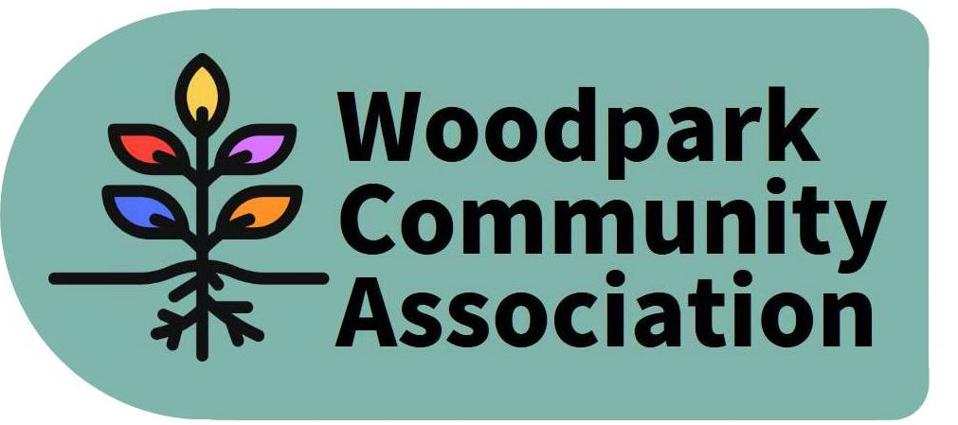
Monthly Meeting – 7 pm, December 9, 2020
MINUTES
Meeting held via Zoom. Minutes taken by Larry
Present: Ian, Stephen, Erica, Celeste, David, Jessica, Tanya, Larry
Absent: Don, Rob, Tom
Guests: Sue Milburn-Hopwood, Art Boni, Alannah Brown
- Agenda with items re-ordered was approved.
- November Minutes were approved with minor revisions.
- Treasurer’s Report – Tanya reported that our account balance was now $1608.
- Tanya reported that her husband’s office was moving and that the space in the Carling Ave. office building would no longer available for WCA meetings.
- President’s Report – Ian reported on matters approved at City Council (Budget, Prince of Wales Bridge Pathway Study, Ward Boundaries) as well as, a community safety meeting he attended along with David and Stephen, he also gave LRT construction updates. WCA agreed to welcome McKellar Park to Bay Ward. Celeste pointed out that safety should encompass more than crime. Woodpark has one Neighbourhood Watch Area in Halldon Place and encourages other areas, however small, that are concerned about crime to organize a Neighbourhood Watch group. Details will be posted on the website. LRT construction is resulting in the extended closure of Byron Ave. and a new crosswalk at Hartleigh Ave. and Richmond Road. WCA is recommending Art Boni and Kate Punnett as Woodpark reps for Community Art projects at the LRT Stations. The Lincoln Fields Planning Study is holding a meeting next week. Woodpark’s interests do not align completely with those of other community associations. This study will incorporate the new Official Plan, a draft of which was released recently, with a 90-day comment period. Ian will undertake to obtain hard copies of the plan while Celeste, Larry and Stephen volunteered to assist Ian with a review of the document and to hold a committee meeting in early January.
- Board Committees – Erica submitted a plan that she, Jessica and Stephen had prepared to reorganize and reduce the number of Board Committees to 4 or 5. She received feedback and will submit a revised plan at the next meeting.
- Woodpark Gift Exchange – Sue reported that approximately 25 households were participating in the gift exchange and that approximately 200 gifts had been collected for residents of Carlingview Manor. This has been a very worthwhile community project.
- Pet Photo Contest – David reported that 47 households participated in the contest in the three (3) subject categories (dog, cat, wildlife) and that donated prizes had been awarded based on votes received. The contest generated a significant increase in visits to the WCA website.
- Winter Picnic – David sought input for a winter community picnic in January. Details TBA. Larry volunteered to assist with organizing the event.
- Potential Dog Park – Larry indicated that he would be contacting neighbours on Edgeworth Ave. to solicit support for the idea.
The meeting adjourned. The next meeting is scheduled for January 13 via Zoom.

