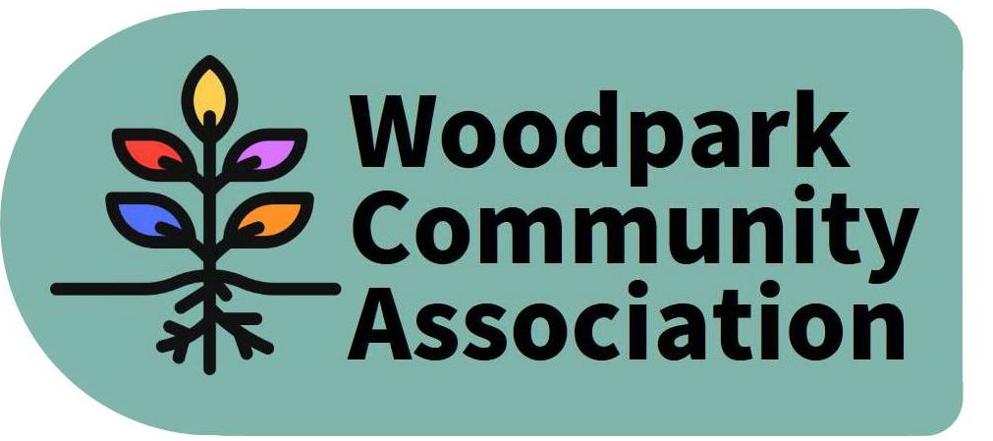
Monthly Meeting – 7 pm, July 8, 2020
MINUTES
Meeting held via ZOOM. Minutes taken by Larry
Present: Ian, Stephen, Celeste, Tanya, Rob, David, Tom, Larry
Absent: Erica, Don, Art (resigned)
- Agenda approved
- June Minutes approved (at end of meeting)
- President’s Report - Ian provided updates on truck routing and the problems of communicating with KEV consortium (KEV treats WCA like an interested rather than affected party and does not engage in bona fide consultation), temporary sidewalk construction (nearly complete), relocation of utilities (to start shortly), Big Dig (expected to start in Jan.), designation of Woodpark as Gateway Community (further reduction of limit to 30 kph would require community petition), installation of planters on Walsh Ave. (expected in 2 mo. as now going through necessary approvals).
- Ian discussed the impacts of proposed changes to Ward boundaries on Woodpark. None of the 5 options were particularly desireable. The methodology was not credible and does not appear to have found much support. Our greatest concerns are being aggregated with dissimilar communities and overall dilution of urban votes. It is expected that more consultation will occur in fall. Meanwhile Ian proposed to circulate a think piece to other community associations. The Board supported this approach.
- The Board discussed proposed submissions on LRT Station Connectivity studies for Lincoln Fields and New Orchard Stations. Generally, WCA and the community has been kept in the dark about current construction plans. The Board approved submissions drafted by Larry concerning Lincoln Fields Station and another by Ian concerning New Orchard Station.
- Zoning and Development:
- Re: 485 Hartleigh - Larry reported on his unsatisfactory responses from City authorities concerning the proposed construction of 2 3-storey dwellings.
- Re: 498 Wentworth - Ian undertook to organize a meeting of neighbours for the scheduled July 22 hearing of an application to the Committee of Adjustment.
- Administrative Matters:
a. Lincoln Fields Station Secondary Plan Study - Larry reported that the study is on a hiatus until the fall when it will be organizing more community sessions. Meanwhile in an effort to provide more community engagement, Britannia CA has created a survey for residents to complete. Larry agreed to circulate this survey to Board with a view to promoting it to community.
b. Community Workshops - Ian has scheduled 2 workshops in September for Board Members to obtain community input on issues WCA should be working on. Later in the month Board Members will have a workshop to plan their activities in the coming term. Feedback to community may occur through another workshop or report.
c. Policing Concerns - Ian did not receive much interest in pursuing generic policing concerns. More outreach to community on security matters sought.
8. Tanya reported that the WCA bank balance, largely as a result of Tom’s fundraising, has now grown to $1461. The Board expressed its appreciation to Tom.

The Board tentatively scheduled its next meeting for August 12 via ZOOM.

The meeting adjourned.

