Minutes  Monthly Board Meeting  Wednesday Oct 13, 2021  7:00pm  Via Zoom |  | 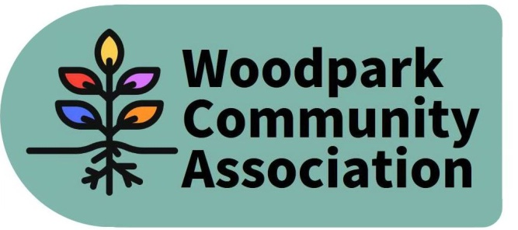
Attendees: Ian McCallum, Robert Hunter, Tanya Krupinicki, Larry Ladell, David Levesque, Tom Marcantanio, Sue Milburn-Hopwood, Jennifer Plank,

Absent: Stephen Kassner, Don Wood

Community Members: Ruth, Janice, Josee and Claire

1 | Call to order  Communicated absences – Donald Wood and Steven Kassner  Addition/Deletions to the agenda – Remarks from Community Members, Official Plan  Review of September Minutes and Action Items – The Minutes of the September meeting were approved without change. The following action items are still pending:  - Convening of Infrastructure and Development Subcommittee and preparation of Terms of Reference for the subcommittee - Don  - Reviewing/editing Terms of Reference for the four subcommittees to ensure a common format ready for Board approval – Sue/David  - Communication to community to seek additional members for Board/subcommittees
2 | Remarks from Community Members  Josee and Claire raised concerns about the functioning of their sump pump likely caused by debris in pipes. They were encouraged to report to the city and it was suggested that Frank Crooks who had addressed another drainage issue for a resident might be a good contact. They also expressed concern about the noise from the construction and lack for noise monitoring. Ian agreed to follow-up with Damon about the location of the noise monitoring devices and the extent to which acceptable levels of noise are being respected.  Ruth expressed concern about the ongoing parking problem and associated safety concerns on Lawn with KEV workers and possibly other people parking on both sides of the street. She had sent a letter to the City but had not received a response. Ian offered to set Ruth up with a contact with the City to explore parking restrictions if there is support by residents. (ACTION ITEM)  Janice indicated that she has learned to live with the LRT construction. She indicated that she had a crack in her ceiling that happened during the major drilling in the spring and is in the process of formally reporting the damage to determine if she can make a damage claim.
2 | President’s Update  Condo on south side of Richmond Road beside NCC lands has suffered damage to its underground parking lot as a result of the LRT drilling. A parking lot will be constructed at the end of Edgeworth to allow the condo residents to park while their garage is being repaired.  Topps Car Wash has been sold to the Dilawri family.  30 story tower is being proposed on Ambleside replacing a surface parking lot and is in the early stage of the approval process.  There continues to be no response from the city about the lack no left hand turn on to Richmond Road from Richardson and right hand turns from Richmond Road on to Richardson. Ian will continue to push to get this address as it allows non resident cars to cut through the community.  Ian indicated that he and Tom had had separate meetings with the Seattle firm contracted to organize the public art in the LRT. Ian was optimistic about the meeting and noted the firm’s interest in using the tree rounds from trees cut for the LTR as part of the art. He also suggested the use of the Westend Studio Tour Group as a mechanism to involve local artists. Tom indicated that he had offered the Seattle firm a tour of the neighbourhood. Next step is a pop-up art display on Bryon next spring. 50 percent of the artists will be indigenous.
3. | Process for Confirming Priorities for Woodpark  - Board discussion/agreement of core priorities  - Consultation with community on board’s core priorities  Sue presented an internal report card on the implementation of the draft WCA Action Plan produced in the fall of 2020 based on priorities identified by the community in Aug 2020. Recommended next steps included communication with the Woodpark Community to reconfirm the priorities and report on recent actions/accomplishments.  A number of board members listed recent accomplishments that should be included in any communication with the community. The value of WCA organized events in promoting the work of the association was also raised.  Ian asked Sue to work with the facilitator who helped the board in the fall of 2020, to determine a process for engaging the community on the priorities identified (ACTION ITEM).
4. | Review of Draft Letter to Anita Vandenbeld – It was agreed to invite Anita to an upcoming meeting of the WCA Board/community to discuss our priorities and her role in helping us achieve them. Ian will draft letter of invitation (ACTION ITEM).
5 | Committee Updates  - Sustainability – Sue indicated that the one project that is being developed is a tree planting project, which is consistent with the priorities of the community. There are also ideas on other potential projects. Sue spoke to the need to recruit additional members to the subcommittee. David volunteered to co-chair the subcommittee and subsequent to the meeting it was agreed that he would be the sole chair.  - Internal Services – David indicated that we have now purchased a Zoom account subscription. Balance will be $1960.91 when the association receives the reimbursement for mural painting.  - Infrastructure & Development – No report  - Outreach & Events – Larry reported on the following events  Oct 23 - Park Clean Up/Pumpkin event – Larry asked Board members to attend. Board supported purchase of leaf bags. David to organize pumpkin pick and temporary storage. Ian will contact the Councillor’s office to seek financial support for clean -up (ACTION ITEM).  Nov - Lantern Walk – Will likely take place the weekend after the time change. Planning is underway.  Dec - Holiday gift giving – Planning is underway.
6 | Other items:  - Training sessions for Board Members on how to use Google Docs, Zoom – David offered to provide one on one training on use of Google Docs.
7 | Adjournment

Next Meeting -November 10, 2021

