WCA Monthly Meeting  July 14, 2021  7:30pm via Zoom  Meeting Minutes  Prepared By: Erica Dath |  | 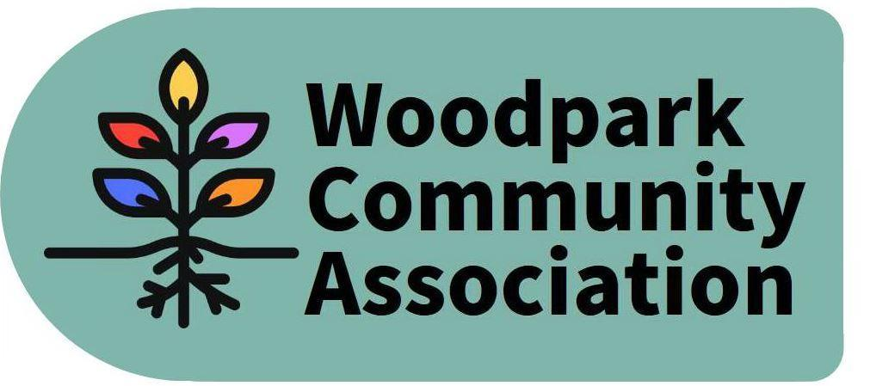
Attendees: Ian McCallum, Larry Ladell, Stephen Kassner, Don Wood, Erica Dath, Tom Marcantonio, Kate Punnett, Jennifer Plank, Sue Milburn-Hopwood, Dave Levesque
Absent: Rob Hunter, Tanya Krupilnicki
1 | Call to Order
 | Communicated absences – Tanya K.
 | Additions/Deletions to the agenda:
2 | President’s Update:  The secondary study is on hold for Official Plan (OP) concerns; city staff now reengaged with anticipated conclusion date of Fall 2021. Lincoln Fields is a transit hub and Woodroffe Avenue is a major corridor. We can anticipate major up zoning along Edgeworth Avenue (west side). The OP will come into effect end of 2021 and the secondary study should complement content of the OP. Woodpark residents are very concerned about potential growth within the neighbourhood as intensification will require major up zoning.  The solid waste master plan consultations are currently ongoing and it is suggested that all citizens participate in consultations, if possible.  Note: comprehension of the full update limited by tech issues.
3 | Committee Updates:  Environment & Sustainability  Committee had meetings - June 28 & July 13  Graham McDonald & Sue Milburn-Hopwood will Co-Chair  Terms of Reference are drafted. To be approved.  The committee strives to promote sustainability, working within community and working in public sector.  An activity took place - traps set to capture gypsy moths, distributed to community members (led by Kate)  Other projects of interest - home energy audits, community composting, tree initiative to increase, social media guru for sustainability committee. The committee plans to have a table at next community event to gather ideas from community.  Action item: Ian to contact other community associations to see what they’re doing in their communities related to environment & sustainability.  Internal Services  David Levesque will Chair.  Terms of Reference are drafted, to be approved.  The Board will use a shared drive to collect and work on shared documents. David will work with any board members to help use the shared drive, maintain knowledge of the CA as a whole (beyond our individual participation).  Sue volunteered to standardize the terms of reference for the various committees. David and Sue will work together to extract governance issues and draft potential bylaw amendments at the December or January board meeting.  Infrastructure & Development  Don Wood will Chair.  No committee meeting held. The Committee will come together before next meeting with status of terms of reference.  LRT construction continues, causing traffic issues at Woodroffe and at Richmond.  451 Ancaster is unsightly, has been under “construction” for several years. Complaint sent to Councillor’s Office and there was recent activity at site. The Building Department was asked to review the permit status of the property.  Street painting done for traffic calming on Ancaster.  Work with Official plan, will be at higher level I & D will be consulted.  Outreach & Events  Committee met on June 16  Sue Milburn-Hopwood will Chair.  Terms of Reference are drafted, to be approved.  The committee meeting included a brainstorming of potential community events:  August – International sit on your porch and play music (Tom to participate)  September 11 (rain date 18th) – Mural painting/street party (Tanya to organize mural painting, event may have music, food trucks). Food trucks have a minimum cost. BBQ is preferred.  November – lantern walk  February – winter picnic in the park  April/May – park cleanup  Committee will discuss events possibilities and present recommendations at next board meeting.
4 | MP & MPP Invite to CA meeting  We should defer our invite to the Fall and outside of campaign time. The invitations should be for separate meetings not both to same meeting. There will likely be elections soon and the elected MP and MPP should be invited within two months of election.  The Board could crowd source community input on topics of interest and discussion for the meetings.  There was a suggestion for WCA to team up with other CAs to determine whether to organize/host an all candidates’ debate. Action item – Ian to reach out to other CAs (east end of Bay Ward) for partnership opportunities.
5 | Treasurer’s Report: No update
6 | Other items:  August meeting: Proposal to cancel August meeting. Ian will be absent. Outreach and Event will meet the week before as community event being planned for September. O&E committee will email board post their meeting if an August meeting is needed to organize event details.  Ottawa Tool Library (Tom): tool library moved to a new location. Board member will distribute postcards.  Approval of June minutes - approved with slight adjustment  Additional: Kate received a letter about the CA and asking whether the Board is doing anything to promote anti-racism within the community or on the Board. The Co-Operator community feels out of touch and unaware of the ongoings in the neighbourhood.  Action item – Larry will contact Ottawa Community Housing to how best to engage residents of co-op.  The Outreach & Events committee will take lead on building inclusive community engagement.
7 | Adjournment

Next Meeting – September 8, 2021

